2028-08-18
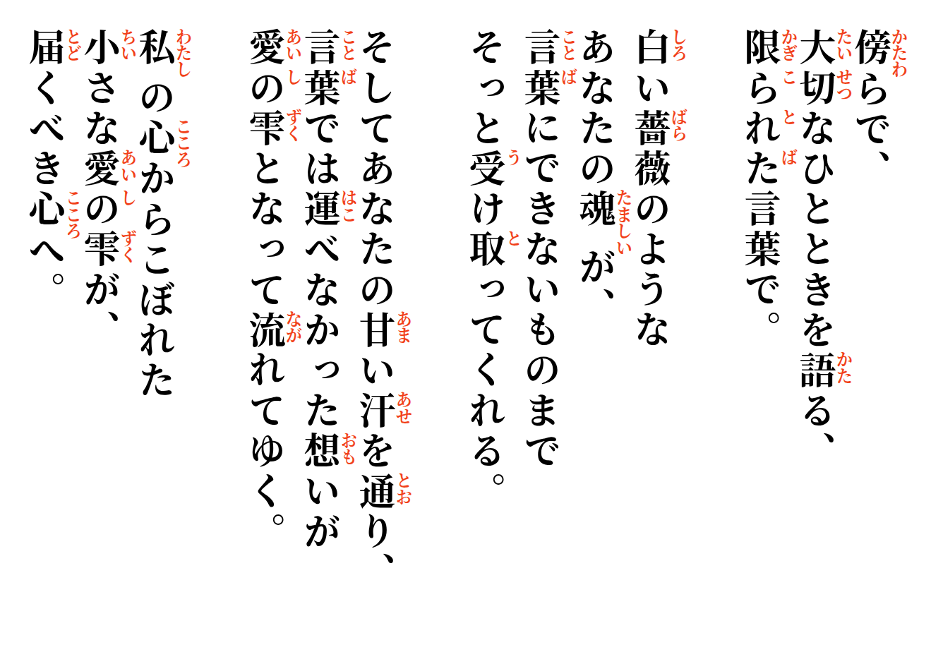
Mitsue


small drops leaving my heart
to reach the hearts intended.
Then, through her sweet sweat, what my words could not carry flows onward as love—
The white rose of her spirit
absorbs what I cannot say.
Beside her, I speak
of a moment I cherish,
with my limited words.

